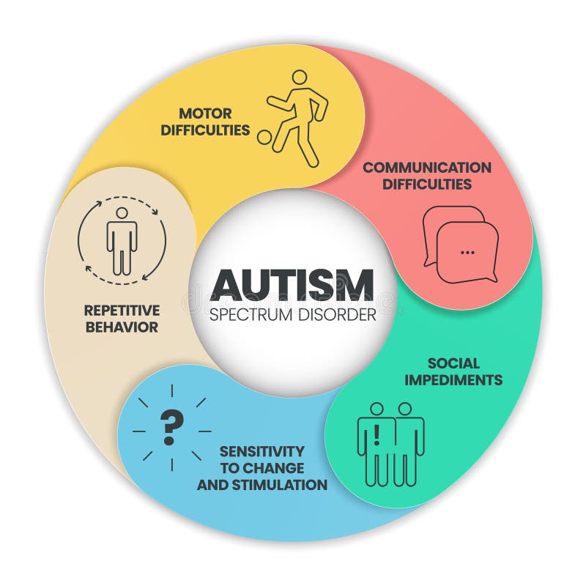

Autism Prediction

Krisha Shah | 60009220055 | Machine Learning -1 | 27-04-24

Aim:
The selected topic focuses on "Autism Prediction," involving the development of a supervised model. To proceed, it is crucial to comprehend the nature of Autism, a neurological condition impacting social interaction, communication skills, and behavioral patterns. However, diagnosing Autism lacks definitive methods, presenting challenges in identification.

Data Description:
The dataset used is Autism Prediction, which has been taken from Kaggle. Relevance: The dataset includes multiple features that are directly or indirectly related to autism prediction, such as age, gender, jaundice, ethnicity, etc.
Variety: It includes both numerical variables (e.g., age, A scores) and categorical variables (e.g. ethnicity, country_of_res, etc.).
Amount of data: The dataset contains 800 rows and 22 columns, providing a substantial amount of information for the model to learn from.
Target Column: The target column for the above dataset is: ‘Class/ASD’
There were no null values or duplicate rows. However there were certain inconsistent values which were handled in the pre processing part.
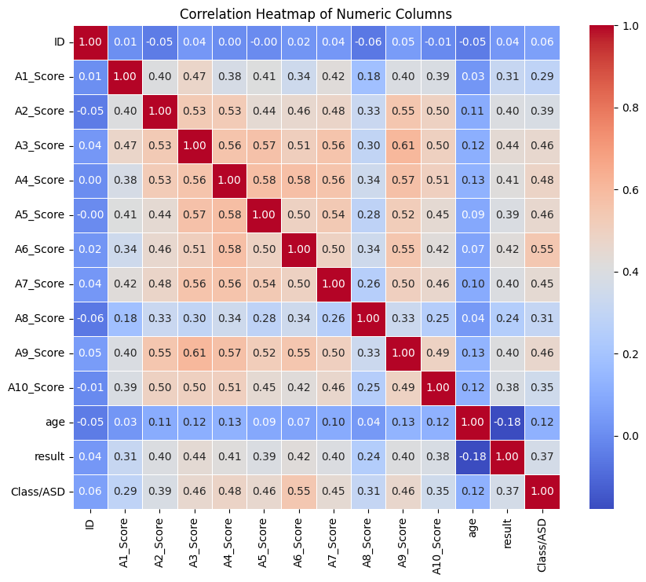
The heatmap analysis reveals several notable correlations within the dataset:
A negative correlation is observed between the 'age' and 'result' columns, indicating that as individuals age, the likelihood of autism diagnosis decreases. This implies that autism tends to be identified at a young age, possibly around 2 years.
A slight negative correlation exists between 'gender_encoded' and 'A2_score', implying that certain attribute scores (e.g., A2_score) are predominantly associated with a particular gender. Further investigation into this relationship may yield valuable insights.
Similarly, a marginal negative correlation is found between 'gender' and 'country', suggesting that specific gender-autism prevalence patterns may vary across different countries.
Positive correlations are observed between the attribute scores (e.g., A1, A2, A3, ..., A10) and 'age', indicating that these attribute scores tend to increase with the age of the individuals.
Notably, the 'Class/ASD' variable exhibits a positive correlation with most factors in the dataset, indicating that these factors collectively contribute to the determination of autism diagnosis.

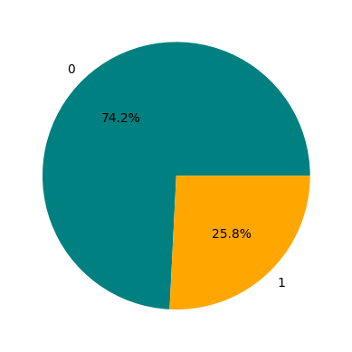
The presented pie chart provides a visual representation of the distribution of binary outcomes, where the value '1' denotes the presence of autism while '0' indicates its absence. It is evident from the chart that a significant proportion of cases exhibit the absence of autism (coded as '0'), whereas a smaller proportion corresponds to instances where autism was detected (coded as '1'). This disparity underscores the prevalence of negative outcomes in the dataset, indicating that a majority of individuals sampled were not diagnosed with autism, while a minority were identified as having the condition.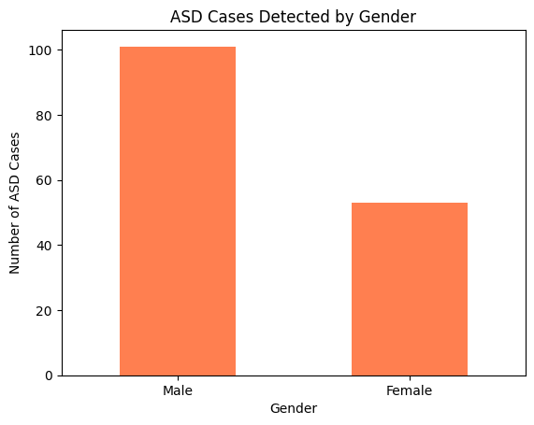
The bar graph provides a visual representation that allows us to observe the distribution of ASD cases among males and females. It distinctly shows a higher frequency of ASD detection in males as opposed to females. This observation prompts further investigation into potential gender-specific factors influencing the prevalence of ASD.

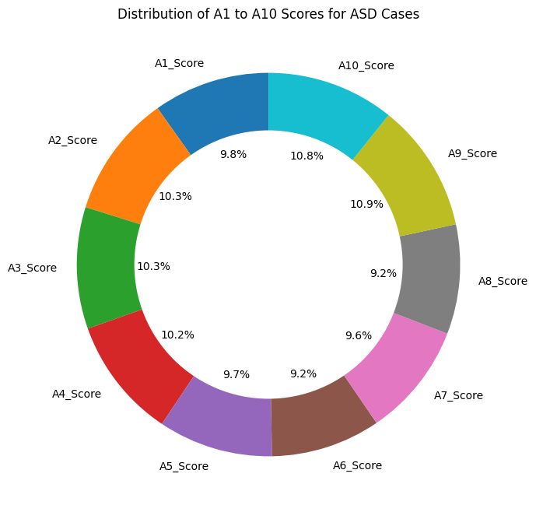
From the above doughnut graph, we can decipher that not all the attribute scores have same kind of impact on te ASD detection.
As per the relation, we can see that A9 has the maximum correlation, followed by A10,A2,A3 and so on and A6 and A7 have the least correlation amongst all.
The above bar graph represents the distribution of ASD Cases country-wise. it can be hence deciphered that the United states have the maximum number of cases, followed by the United Kingdom, Canada, Australia and Afghanistan. Whereas the least amount of cases have been recorded in Iran, Bahamas,Oman, Austia and Ethopia.
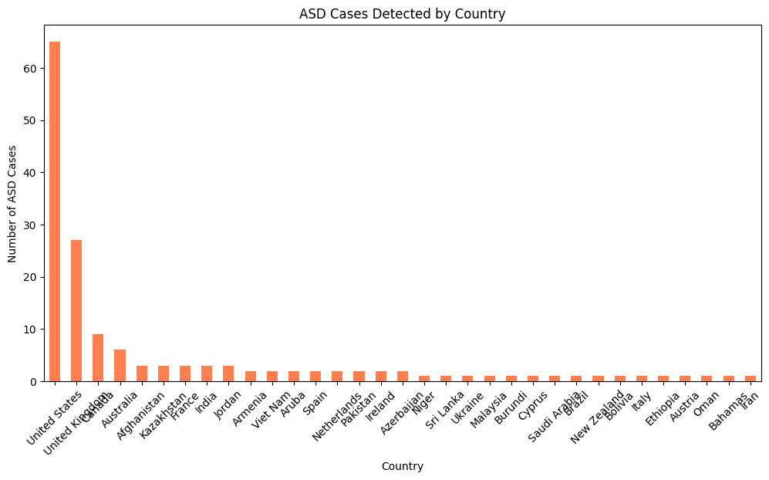
The above bar graph represents the distribution of ASD Cases country-wise. it can be hence deciphered that the United states have the maximum number of cases, followed by the United Kingdom, Canada, Australia and Afghanistan. Whereas the least amount of cases have been recorded in Iran, Bahamas,Oman, Austia and Ethopia.
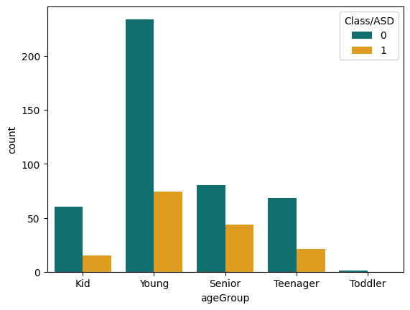
The above countplot shows a distribution od ASD across different age groups. People with ages between 18 and 40 that is the young people have shown more number of cases of this disorder, followed by the Senior age group, that is people having ages more than 40 years.
It can also be seen that toddlers have recorded the least number of cases followed by kids and then teenagers.

Data Pre-processing:
In the preprocessing phase, the primary objective is to eliminate noise, which refers to any irrelevant or inconsistent data present in the dataset. This noise can manifest in various forms, such as non-numeric characters or erroneous entries. For instance, in the 'age' column, encountering entries like 'yes' instead of numerical values indicates noise. Additionally, handling missing data is imperative during this stage. Data tokenization is then performed to segment the information into smaller, more manageable units.
Subsequently, Exploratory Data Analysis (EDA) is conducted to ensure accurate data filtration, essential for building reliable models. Skewness of the data is assessed, and common attributes associated with individuals with autism are identified. Visualization techniques are employed to illustrate data distribution, with multivariate analyses facilitated through tools like heatmaps and parallel components.
Following EDA, feature engineering is initiated, involving the extraction of relevant features from the textual data, such as frequency. Transforming textual data into numerical representations is achieved using methods like TF-IDF (Term Frequency-Inverse Document Frequency).
For model selection and training, given the classification nature of the project (predicting the presence or absence of autism), models such as logistic regression, random forest, or support vector machines (SVM) are suitable choices. The dataset is partitioned into training, validation, and testing sets to evaluate the model's performance. Evaluation metrics such as F1 score, accuracy, and confusion matrix are employed to assess the model's effectiveness.

Data Modeling:
The performance of several models has been calculated, including decision tree, random forest, SVM, XG-Boost and logistic regression. Among these models, the random forest (RF) model consistently demonstrated the highest accuracy. Even after performing hyperparameter tuning to optimize training and testing accuracy, the RF model remained the top performer.
For performance evaluation, I employed various scoring metrics such as recall, precision, accuracy score, and confusion matrix. Given that the dataset contained 17 features for predicting the independent variable, I employed Principal Component Analysis (PCA) to reduce the dimensionality from 17 features to 5 features, selecting the best combinations to retain the most significant information.
Following dimensionality reduction, I retrained the random forest model using the reduced feature set. Subsequently, I deployed the optimized random forest model using Flask, leveraging the pickle module for serialization.

DATA EVALUATION:
After fitting the models, it's evident that the Support Vector Classifier (SVC) is not an optimal choice due to its lower accuracy of 68%.
Among the remaining models – Logistic Regression, XGBoost, and Random Forest – all show promising results. However, the Random Forest model stands out with the highest accuracy of 75%.
We proceed with evaluating the Logistic Regression model, which achieves an accuracy of 76%. The precision, recall, and F1-score for both classes (0 and 1) are computed and presented:
Precision for class 0: 0.85
Precision for class 1: 0.60
Recall for class 0: 0.78
Recall for class 1: 0.71
F1-score for class 0: 0.82
F1-score for class 1: 0.65
The confusion matrix illustrates the model's performance in predicting true positives, true negatives, false positives, and false negatives:
[[64 18] [11 27]]
Similarly, the evaluation metrics for the Support Vector Classifier (SVC) are calculated, revealing its limitations compared to other models:
Precision for class 0: 0.72
Precision for class 1: 0.50
Recall for class 0: 0.89
Recall for class 1: 0.24
F1-score for class 0: 0.79
F1-score for class 1: 0.32
The confusion matrix for SVC is:
[[73 9] [29 9]]
The same evaluation process is repeated for other models, including XGBoost and DecisionTree, providing insights into their performance metrics and confusion matrices.
Also, after performing PCA, the accuracy turned out to be 91% and further the random forest accuracy turned out to be 0.81 which is a sufficiently good score.

DEPLOYMENT:
